Ideation Phase
Brainstorm & Idea Prioritization
Date | 29 September 2026
Team ID | SWTID-2026-2597
Project Name | Streamlining IT Procurement – Automating Standard Laptop Orders with Flow Designer
Maximum Marks | 4 Marks
Brainstorm & Idea Prioritization Template
The team identifies the main challenges in the standard laptop procurement process and explores ideas that can reduce manual work, improve assignment, and speed up laptop configuration.
Step-1: Team Gathering, Collaboration and Select the Problem Statement
- Identify delays and manual steps in the current Standard Laptop request process.
- Discuss the need for automatic Catalog Task creation after the Service Catalog request is processed.
- Identify the need to assign configuration work directly to the Hardware team.
- Consider approval verification and request tracking as important control points.
Step-2: Brainstorm, Idea Listing and Grouping
- Automated Catalog Task creation using Flow Designer.
- Automatic assignment to the Hardware group.
- Standardized laptop procurement workflow.
- Approval verification before configuration.
- Faster laptop configuration after task creation.
- Reduced manual intervention and fewer missed tasks.
Idea Prioritization
Idea | Impact | Implementation Focus
Automated Catalog Task creation | High | Flow Designer
Hardware team assignment | High | Assignment Group = Hardware
Reduce manual intervention | High | Automation
Approval verification | Medium | Approved request
Faster laptop configuration | High | Prompt task handoff
Standardized workflow | High | Service Catalog + Flow
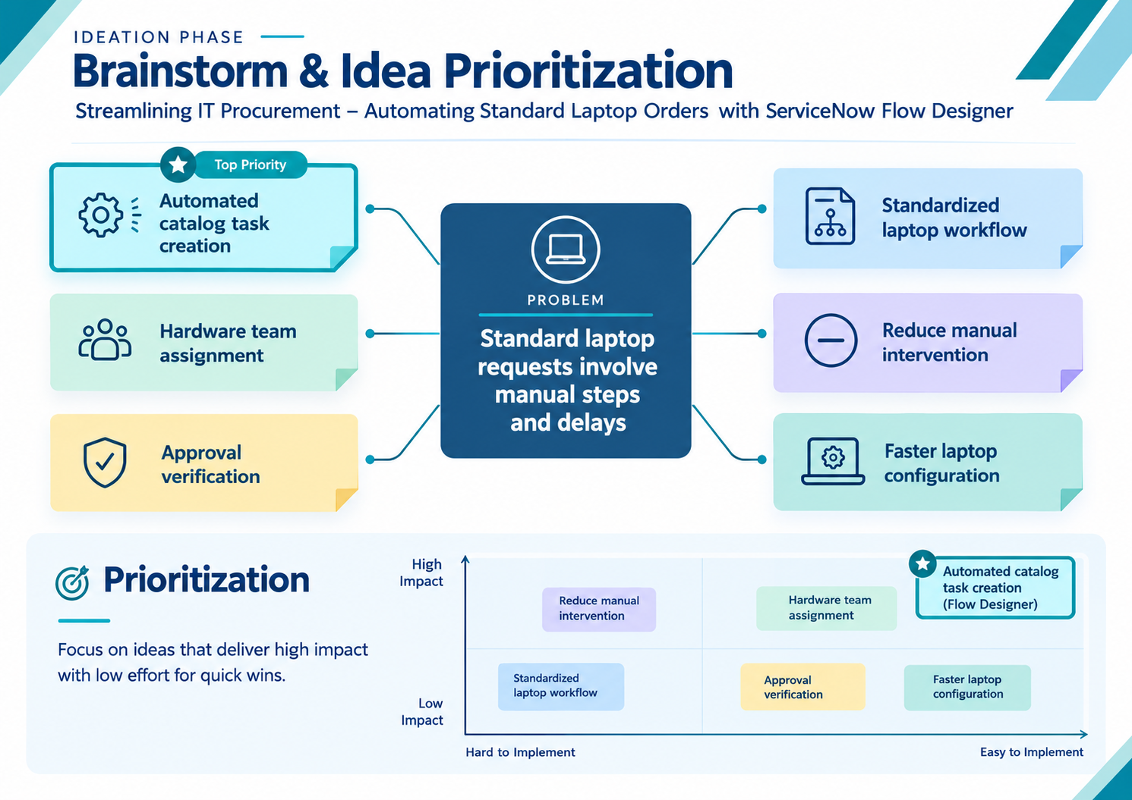
Figure 1. Brainstorming and idea prioritization for the Standard Laptop procurement process.

